Instalare driver ODBC in PostgreSQL:

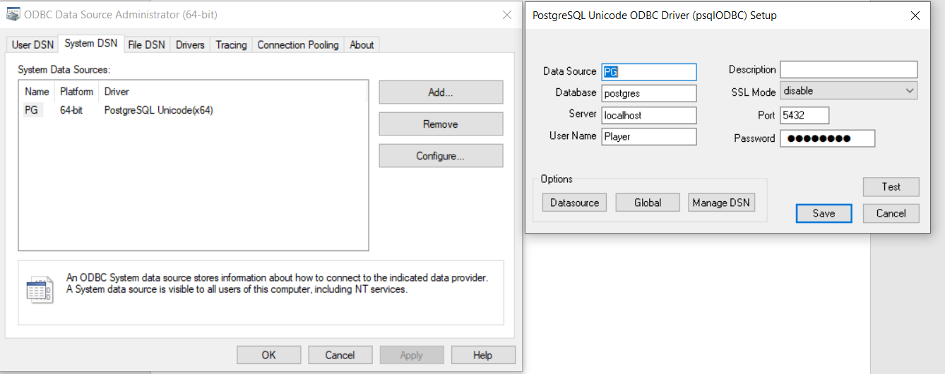

Crearea instanței remote PostgreSQL:

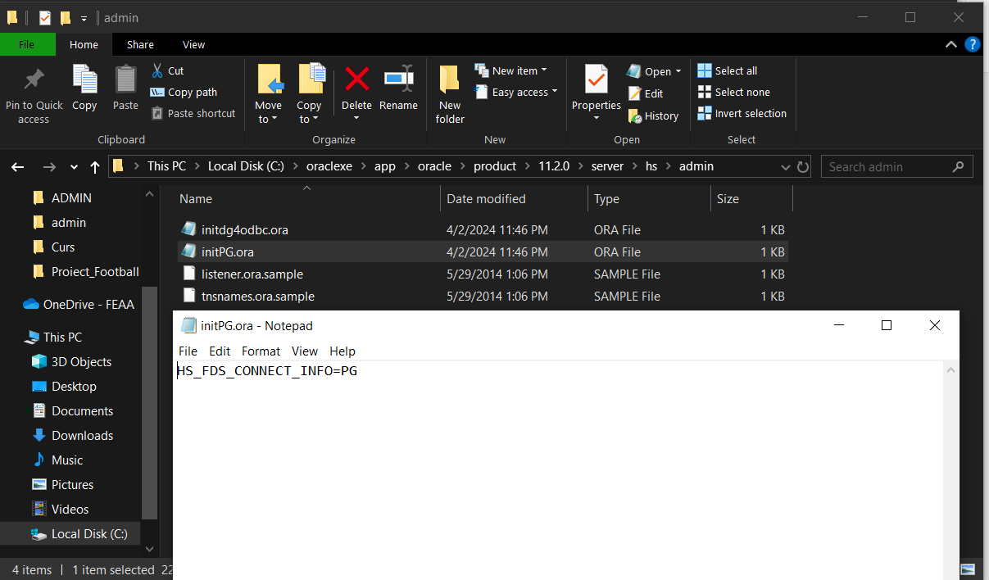

Editarea fișierului listener.ora din ORACLE_HOME:

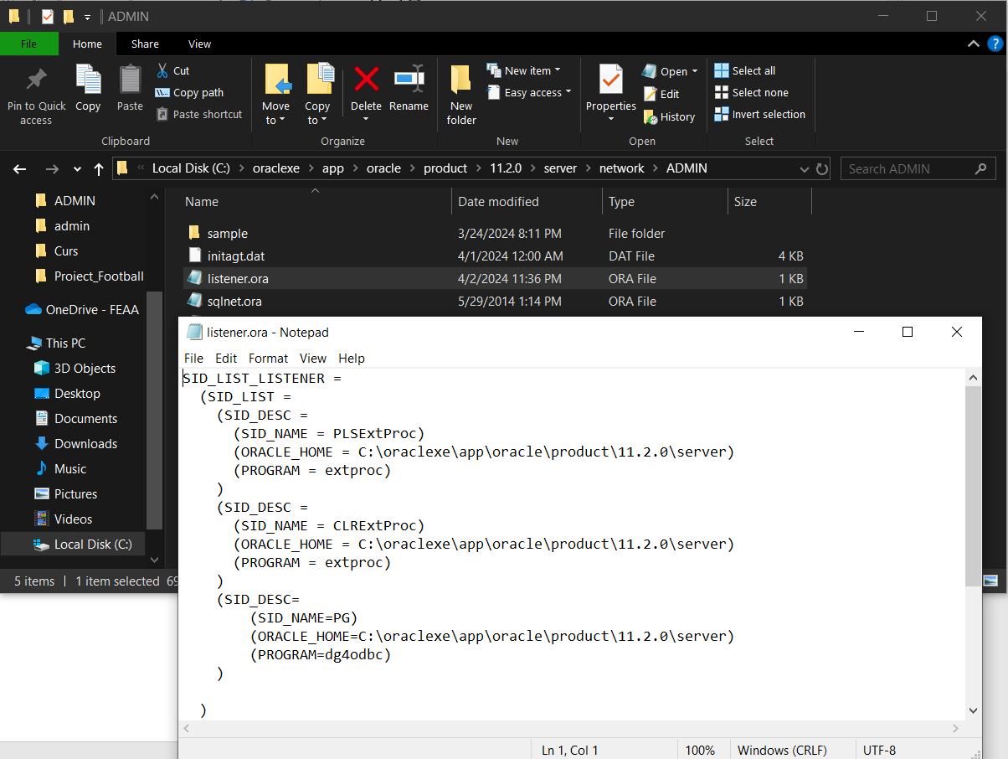

Editarea fișierului tnsnames.ora din ORACLE_HOME:

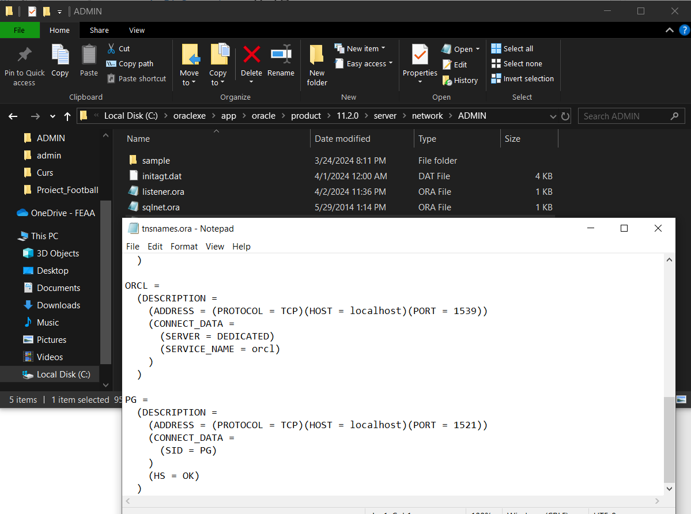

Comenzi SQL din SQL Developer:

ROLLBACK;

ALTER SESSION CLOSE DATABASE LINK PG;

DROP DATABASE LINK PG;

CREATE DATABASE LINK PG

CONNECT TO "postgres" IDENTIFIED BY postgres

USING '(DESCRIPTION =

(ADDRESS = (PROTOCOL = TCP)(HOST = localhost)(PORT = 1521))

(CONNECT_DATA =

(SID = PG)

)

(HS = OK)

)';

------------------

select * from user_db_links;

select

"id_player" as id_player,

"name_player" as name_player,

"position_played" as position_played,

"id_team" as id_team

from "player"@PG

ORDER BY id_player;

CREATE OR REPLACE VIEW players_view AS

select

"id_player" as id_player,

"shirt_number" as shirt_number,

"transfer_value" as transfer_value,

"name_player" as name_player,

"position_played" as position_played,

"id_team" as id_team

from "player"@PG;

SELECT * FROM players_view ORDER BY id_player;

SELECT * FROM TEAMS;

--DROP TABLE PLAYERS_TEAMS;

CREATE OR REPLACE VIEW PLAYERS_TEAMS AS

select

t."ID_TEAM" as id_team,

t."NAME_TEAM" as name_team,

-- details

p.id_player as id_player,

p.name_player as name_player,

p.position_played as position_played

from teams t

INNER JOIN players_view p

ON p.id_team = t.ID_TEAM;

SELECT * FROM PLAYERS_TEAMS;